Jurnal Disastri:
Pendidikan Bahasa dan Sastra Indonesia
Vol 5, No. 2, Desember 2023
http://ejournal.unhasy.ac.id/index.php/disastri
EISSN:2722-3329, PISSN:2716-411X

Sarcasm Depiction of Ferdy Sambo's Object in Tempo Magazine: Pierce in Visual Signs

¹Marisa Putri Prawianti, ²Rizki Endi Septiyani, ³Mas’an Hamid
^{1’2’3}Universitas Islam Negeri Sunan Ampel Surabaya

Corresponding Author: ¹ marisaputriprawianto@gmail.com

Abstract
This research aims to examine the use of sarcasm in the depiction of Ferdy Sambo objects in Tempo magazine. Pierce's semiotic approach is used as a theoretical framework to analyze the visual signs used to convey sarcasm. This investigation categorizes various types of signs in semiotics, including icons, indices and symbols, which appear in Ferdy Sambo's depiction of objects. In addition, this research explores the role of sarcasm as a communication strategy in expressing criticism of Ferdy Sambo's actions or attitudes regarding relevant social or political issues during that period. The research methodology used is qualitative analysis of two covers of Ferdy Sambo's special edition of Tempo magazine. The data collection process uses documentation methods, recording techniques, and screen capture methods. Based on the analysis findings, it appears Tempo magazine uses sarcasm when describing the Ferdy Sambo object, which shows a critical response to existing social and political problems. Sarcasm functions as a means of communication to express disagreement and criticism of Ferdy Sambo's behavior.
Keywords: sarcasm, visual signs, Pierce semiotics, Ferdy Sambo, Tempo Magazine.

Article history
Received:  18-10-2023 | Revised:  15-11-2023 | Accepted:  30-11-2023 | Published:  20-12-2023

Introduction
The presence of the media and public access make the media a very strategic channel in providing information without any obstacles for the people who also use the media. Through this channel, mass media is the only institution that is able to reach more people and convey information and knowledge to the public than other institutions. With the power of mass media, existing events can be transcended by penetrating distances of space and time. Many powerful interest groups use the mass media as their ideological force to encourage the formation of opinions based on their own reality. One of the uses of mass media is as a communication tool, and can also be used to criticize a group of officials. Through reporting, the media can find out how readers view an event and find out who the actors behind the event are.
Sobur wrote in his book that mass media is not something free and independent, there are various interests behind it. This fact makes news bias in the mass media unavoidable (2013, p. 30). Sobur further quoted a quote from Aart van Zoest's book which stated that "journalistic texts are never free from ideology or the ability to manipulate readers towards ideology (1991, p. 70)." Eriyanto agrees with Sobur, in his book he writes that the media is not an free channel or even a mirror of reality. Reality is formed or constructed, while the media is what shapes that reality (Eriyanto, 2012, pp. 15-18).
In this research, the author used Tempo magazine as an object because it is considered a mass media that often uses caricatures in the form of satire on its magazine covers, which of course has an important purpose to provide information to the public in various fields. The focus of this research is on the cover illustration of the special edition Ferdy Sambo magazine. The reason is, this case raises many questions and is able to shock the nation. Each edition of Tempo magazine will feature an illustration on the cover, with the aim of conveying meaning to readers. Signs and symbols in illustrative works are a unique attempt to transform the message.
Tempo is the only mass media that publishes special editions in print and digital format. Based on research by researchers, other mass media such as Gatra.com, Kompas.com, Detik.com, Liputan.com also published articles about the Ferdy Sambo case, but did not receive special edition assignments, and did not provide as much and in-depth information as Tempo. Apart from that, it is interesting to know how Tempo illustrates this case. Tempo coverage of the Ferdy Sambo case was widespread, starting from the handling of the crime scene (TKP), the suspicions of the RT head, to the statement by the Coordinating Minister for Political, Legal and Security Affairs on July 13 2022. The Kemenkokam said on Sunday that the shooting that occurred at the house of Ferdy Sambo, the former Head of Propam, was full of with irregularities, the causes and reasons that have been handled are explained by the National Police themselves. Tempo.co's editorial policy itself is a rule agreed upon by the editorial team, which is determined when the news is presented. Of course, Tempo is very much based on journalistic ethics and has become Tempo's guidelines, so that the news written can comply with the code of ethics, cover both sides, not be vulgar, and not be judgmental, meaning that Tempo can apply what is called covering both sides, then not make or judge someone as Tempo wants to present news.
To be able to represent the Ferdy Sambo case on two covers that have been chosen by researchers in Tempo magazine using a semiotic approach by Charles Sanders Pierce, so that all the signs in the image can be classified into three groups, namely icons, indexes and symbols. In order to reveal the information content contained in the Tempo cover illustration of the Ferdy Sambo edition, the research entitled " Sarcasm Depiction of Ferdy Sambo's Object in Tempo Magazine: Pierce in Visual Signs". Based on the background explained by the author, the scope of the research is limited to the cover of Ferdy Sambo's special edition of Tempo magazine. Which describes a series of codes for cases of police shooting police. Apart from that, researchers also use sarcasm in analyzing the object. Sarcasm is a type of harsh language in the form of ridicule or affirmation of someone's attitude, for example someone who expresses irritation and anger towards another person. Through this, the researcher will also highlight the framing or depiction of Ferdy Sambo made by Tempo magazine.
The previous research that was found and if it matches the current research is as follows:
- First, Nugroho Abraham Akbar conducted research entitled "Analisis Semiotik Sampul Majalah Tempo Juli 2018 Edisi 4-11". The author uses a qualitative research approach with Charles Sanders Pierce's semiotics by focusing on magazine covers so that in the image you can see the types of signs that are classified as semiotics. Among them: icons, indexes and symbols.
- Second, a study conducted by Andriyan Ruslan Ramli with the title " Analisis Semiotik Sampul Majalah Tempo Edisi 9-15 Maret 2020". This study discusses the Covid-19 pandemic in Indonesia since March 2020. The government has received public input through Tempo magazine regarding the policies taken to overcome this pandemic. This research aims to use Pierce's semiotic analysis model to reveal information about the meaning of the cover of Tempo magazine.
- The third article was written by Azhar Natsir Ahdiyat with the title “Analisis Semiotik Visual Ilustrasi Sampul Majalah Tempo Edisi 2021: Jerat Kedua”. This research aims to explain the structure of visual symbols on the cover illustration of Tempo Jerat Second magazine. Apart from that, the aim of this research is to reveal the codes contained in the cover illustration. The method used is visual semiotics, based on Roland Barthes' semiotic theory, including the structure of visual signs and Barthes' five codes. Thus, the structure of the Tempo Magazine edition of "Jerat kedua" consists of denotative signs whose meaning is changed into connotative signs. The connotative meaning that emerges is based on conventions, anchoring of meaning, gestures/expressions, rhetorical use of metaphor/metonymy, and realistic references. The codes revealed on the cover of this magazine include hermeneutical, semantic, professional, symbolic and cultural codes.
- The fourth article was written by M. Wildan entitled " Sentimen Negatif Netizen Terkait Pemberitaan Kasus Ferdy Sambo di Kolom Komentar Detik.com Tahun 2023." This research aims to describe the negative sentiments of netizens in the Detik.com comments column as a response to news about the fabricated case, the determination of the suspect, and the Disrespectful Dismissal (PTDH) of Ferdy Sambo. The findings revealed that netizens had negative sentiments regarding detikcom's reporting regarding Ferdy Sambo's engineering of the alleged murder of Brigadier General J, the National Police's naming of Ferdy Sambo as suspect, and his dishonorable dismissal (PTDH) from the National Police Agency.
From the four previous studies mentioned, it was found that there were several similarities and differences with current research, where of the four studies above, all of the research involved visual analysis. Both rely on visual observation, document analysis, and interpretation to reveal meaning and understanding in the context of the research subject. Meanwhile, the differences found were in the research object, where this research was related to sarcasm in the depiction of Ferdy Sambo's object on the cover of Tempo magazine, while the three previous studies focused on semiotic analysis of Tempo magazine covers related to different topics. So a gap was found in the research focus, namely Ferdy Sambo's sarcasm in the depiction of objects in Tempo magazine which had a different focus from previous research.
Method
Researchers use Piircean semiotic methods and sarcastic language as an analytical framework. Based on a critical paradigm that seeks a tapered and comprehensive analysis of existing reality. This critical approach uses more real events and logic to understand meaning. This research data is in the form of visual symbols. The research data is qualitative from Tempo magazine. Tempo continues to produce versions of the Ferdy Sambo, some of which were selected for research data because they were deemed to meet research data standards. Researchers limited their study data to two covers containing caricatures and narratives. Data is combined through documentation methods using note-taking and screen capture techniques. The study data is qualitative data sourced from Tempo magazine. Starting from the launch of the first Ferdy Sambo special edition starting on July 16 2022. Tempo has produced Ferdy Sambo editions continuously, so that some of them were selected as research data because they were deemed to have met the research data criteria. From several covers found, the researcher limited the research data to two covers containing caricatures and narratives.
Researchers use note-taking techniques to present written data in preparation for analysis. At this stage, the writer will note down every narrative or sentence on the cover of Ferdy Sambo's special edition of Tempo magazine. The process is to copy the contents of the text. Screen capture technique as symbolic notation in visual Sambo on research data. The screen capture process was carried out on the image chosen by the researcher as an anticipation in case of problems with the quota signal running out. Apart from that, it also collects relevant Tempo magazine journals and other references related to the research object. Analyzing the visual signs contained in Ferdy Sambo's object images, identifying sarcastic elements, symbols, and the relationship between all these signs. Then relate the signs to the context of the Tempo magazine with Pierce's semiotic theory.
Result and Discussion
- Sarcasm
The use of sarcasm includes a linguistic approach in the form of words that are unpleasant to hear, resulting in a decline in social standing or other forms. The use of sarcasm is simply a manifestation of someone's presence, whether it is to gain recognition, convey certain sentiments, or express dissatisfaction with something.
- Tempo Magazine
Tempo magazine, which is famous for its penchant for incorporating sarcastic elements into its magazine cover caricatures, has again utilized this approach in its special edition featuring Ferdy Sambo. The focus of this edition is a series of murder cases involving the former Inspector General and his subordinates, especially Nofriansyah Yosua Hutabarat. Through its coverage, Tempo Magazine wants to reveal the dark history of the former general. Tempo stands as an autonomous publication and is not influenced by external forces, whether individuals or institutions, and as a body to fight for the right to speak for everyone without exception.
In this research, two covers of Ferdy Sambo's special edition of Tempo magazine will be studied through Charles Sanders Pierce's sign theory, which has been grouped into three types: sign, object, and interpretant. The covers analyzed are as follows.
- Edition 13 August 2022, with the cover title " Bukti Baru Pembunuhan Brigadir Yosua”
- Edition 19 February 2023, with the title " Kasak Kusuk Sebelum Vonis"

- Pierce’s Theory
According to Charles Sanders Pierce, semiotics can be understood as logic, especially the formal study of signs. Signs are not only an integral part of language and communication systems, but also connect the world with the human mind. All human reasoning essentially relies on signs, which means that our ability to think and understand the world cannot be separated from the use of signs.
According to Pierce, semiotics falls under the umbrella of philosophy. He equates logic with semiotics and believes that semiotics can be used to analyze various types of symbols (Berger, 2001: 11-22). As time goes by, the term semiotics becomes more popular than semiology. For Pierce, semiotics is just the name for logic, namely the formal doctrine of signs.
Pierce's theory states that a sign functions as a representation of something else, known as an interpretant, and this first sign is connected to the object it refers to. Therefore, there is a direct and conventional relationship between the sign or representation and the interpreter and object. The process called semiosis involves the combination of representations and objects, which is often called signification.
Pierce is best known for his theory of meaning, known as the triangle theory. In this theory, semiotics is based on three fundamental components: signs (representations or symbols), the focus of the sign (object), and the user of the sign (interpretant). The triangle theory explores the origins of symbols used in communication. These signs have real manifestations that can be felt through the human senses and function as representations of other entities.
Discussion
Found on the cover of Tempo Magazine for the week of August 13 2022, entitled "Bukti Baru Pembunuhan Brigadir Yosua", you can see in the image that the icon is a picture of Sambo sitting with his hands linked, with his face covered by a roll of film.
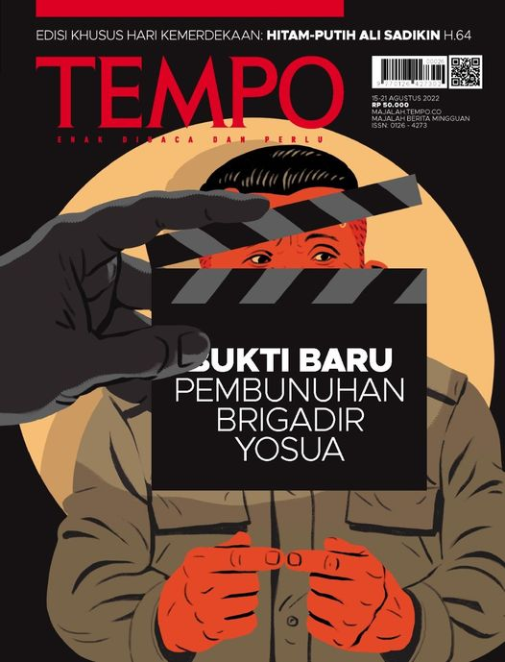
Picture 1
Cover of Tempo Magazine August 13, 2022 edition
The classification of analysis findings is rooted in sign categorization, especially Qualisign, which indicates the quality of the sign, which includes descriptors such as sarcastic sentences or subtle language. The qualification in the image above shows that the background color of the image is black. The calm expression in his eyes indicated that it was as if it was not Sambo who committed violence against Brigadier Yosua, but rather his subordinate, namely Bharada Richard Eliezer. However, the black color also indicates that Sambo's figure is weak, his energy has run out and he is dirty. This is related to Ferdy Sambo's imprisonment at Headquarters of Mobile Brigade, especially as the testimony given was not accurate. Meanwhile, the yellow background refers to cooperation, and also uncertainty, this is proven by the alleged bribery to protect Sambo, with uncertainty regarding what was said in court.
In a sign, namely the existence of real objects or events contained in the sign. The sign in the picture above is the figure of Ferdy Sambo covered in a roll of film with his eyes looking to the left. Illustrating that he was not alone in engineering all the events. Meanwhile, Legisign is a rule in a sign, for example traffic signs, which means that something cannot be done by humans. The legisign on the magazine cover above is a picture of a roll of film held in someone else's hand, indicating that the murder was staged and there was a mastermind behind it all, proof that there is a big lie in it.
The analysis findings come from Object classification, which specifically focuses on icons that can be identified by users due to their visual similarity. The icon displayed on the cover of the magazine depicts Ferdy Sambo who is depicted in neat clothes and holding his hands together with his hair neatly styled. The sign index displays an extraordinary and existential correlation between the representation and its object. The image displayed on the top cover shows Sambo, with his hands interlocked, symbolizing his innocence in action. The symbol in question is a sign that was deliberately created as a reference, based on an agreement or agreement that has been established regarding the relationship between the signifier and the signified. In this case, the symbol is represented by the special phrase "Bukti baru pembunuhan Brigadir Yosua".
By using block letters, and in the sentence "Bukti Baru" which is bolded in white, white can be interpreted as peace, as well as an apology. In this case, Tempo is very skilled at designing its typography so that it looks pleasing to the eye and is certainly able to facilitate the reader's understanding of visual communication media. As well as strengthening the verbal meaning he wants to convey. So it can be understood that the index, firstly, the image of Sambo's hand link indicates that he is acting innocently and doesn't know anything about the shooting incident, secondly, the film roll image indicates that the shooting was staged or a scenario has been prepared, thirdly, Sambo's eyes are glancing to the left, indicating that Sambo didn't plan alone and was watching the other colleagues in Yosua's shooting. The hand holding the roll of film indicates that it was not Sambo who engineered or compiled the scenario but that there was the mastermind behind Brigadier Josua's death, namely PC's mother. Meanwhile, the symbol which means language is located on the cover title "Bukti baru pembunuhan Brigadir Yosua".
The author's interpretation of the explanation of icons, indexes and symbols shows that the Tempo magazine cover design above is an explanation of the case of the engineered murder of Brigadier Yosua. The sign on the magazine cover is the figure of former Inspector General Ferdy Sambo wearing neat clothes and smooth hair. Indicating that he was the controlling figure in the engineering murder case he committed. However, in the end it was slowly revealed, this was reinforced by the sentence perched on the cover title above, namely "Bukti baru pembunuhan brigadir Yosua.” In this way, the tempo frames the cover with codes or signs whose true meaning is in accordance with what is happening and visible to the public. Don't forget that Tempo also put a sarcastic element into its visual image, namely the image of Sambo's eyes glancing with clear strokes and lines, indicating that Tempo has inserted a sarcastic element through Ferdy Sambo's glancing eyes, as well as the visual which is depicted with smooth hair and an index finger. intertwined with each other, indicating that he looks like a geek or an innocent person.
In the February 19 2023 edition of Tempo Magazine, with the title "Kasak kusuk sbelum vonis." The figure of Sambo is shown standing facing forward carrying a gun.
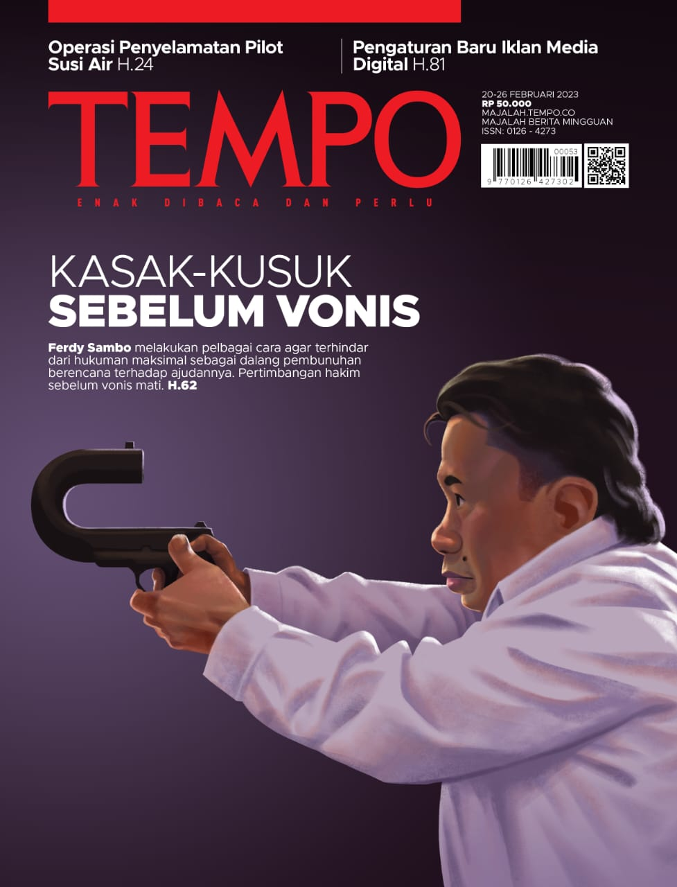
Picture 2
Cover of Tempo Magazine edition 19 February August 2023
In accordance with the magazine cover above, it shows Sambo's face from the side which is focused and tense, wearing a white shirt and long hair. The qualification in picture 2 is the words "Kasak kusuk sebelum vonis" in white writing which indicates achievement. Here, Tempo gives a white sign with the meaning of the achievements of law enforcers and the investigation into the case of Brigadier Josua's death, which is slowly starting to come to light. The sign in picture 2 is a picture of Ferdy Sambo holding a gun that is curved towards himself, indicating a weapon for you. Which all predictions have been wrong. Many of his lies were exposed.
The legisign on the cover of magazine 2 is Tempo's visual depiction of Ferdy Sambo who looks sarcastic with glaring eyes, because he is afraid of the sentence that will be handed down to him. Because of that, he legalized various methods that he considered reasonable, so that he would not be charged with full punishment for his role as the mastermind behind the murder. In the sense that Sambo does not want to take full responsibility for his mistakes, this is justified by the 4 lines of sentences below the cover title. Which says “Ferdy Sambo melakukan pelbagai cara agar terhindar dari hukuman maksimal sebagai dalang pembunuhan berencana terhadap ajudannya. Pertimbangan hakim sebelum vonis mati. H.62”
It can also be understood that the first index in Figure 2 is Sambo's face seen from the side, illustrated by Tempo with a tense expression without a smile, with his eyes glaring forward, indicating an alert and ambitious attitude towards the enemy and defending the case he continues to carry out. Second, the image of the hand carrying the gun curved towards him in a shooting style position, indicating that the event that had been engineered had turned around and hit him, as the term eats the gun. The third is Sambo's position which is brave and ready, and continues to face forward without looking back, indicating that Sambo is only focused on his goal so he forgets the people in him who can thwart his plans. The symbol obtained in Figure 2 is the sentence "Kasak kusuk sebelum vonis". There is also a sarcastic element which is not forgotten to be inserted in the sentence written under the cover title 2, the words "Sebagai dalang pembunuhan berencana terhadap ajudannya.” It doesn't stop there, we can also clearly see the sarcastic element in the visual of the gun that Sambo is carrying with a curved shape like an umbrella handle, indicating that this weapon has no merit for him.
The author's interpretation of the cover of the February 19 2023 edition of Tempo magazine is Sambo's steering wheel regarding the police shooting case which he had the heart to commit. He fabricated and sabotaged all the evidence, but he forgot to predict his own lies. The white shirt illustrated by Tempo for Ferdy Sambo was also a sign that he would soon be arrested. The use of sarcasm in the depiction of 2 visual objects about Ferdy Sambo in Tempo magazine can be understood as an effective communication strategy. Tempo Magazine succeeded in conveying a sharp and critical message about this case. In this case, Ferdy Sambo's depiction of objects with sarcasm can be considered a form of expression of critical opinion towards the subject being displayed.
Conclusion
Through the application of Pierce's semiotic approach, research conducted on the depiction of Ferdy Sambo's objects in Tempo magazine shows the use of sarcasm as a means of expressing criticism and dissatisfaction with Ferdy Sambo's actions and attitudes relating to contemporary social and political issues. Pierce's semiotic approach offers a relevant framework for analyzing the visual signs used in the depiction of such objects, highlighting the inseparable relationship between signs and logic, helping in understanding how visual signs can convey messages implicitly.

References
Berger: 2011: http://islamicgraphicdesign.blogdetik.com).
Budiman, K. (2003). Semiotika visual. Yogyakarta: Buku Baik dan Yayasan Cemeti.
Eriyanto. (2001). Analisis wacana: Pengantar analisis teks media. Yogyakarta: PT LKiS Pelangi Aksara.
Fatimah. (2020). Semiotika dalam Kajian Iklan Layanan Masyarakat (ILM). Gowa : Gunadarma Ilmu.
Kris Budiman, Semiotika Visual: Konsep, Isu, Dan Problem Ikonsitas,
(Yogyakarta:Jalasutra, 2011).
Prajarto,Nunung.(2018).Netizen dan Infotaiment: studi Etnograf Virtual pada Akun Instagram “Lambe Turah”. Jurnal Ilmu Komunikasi. https://ojs.uajy.ac.id/index.php/jik/ar ticle/view/1367
Sumbo Tinarbuko, semiotika komunikasi visual, (Yogyakarta:Jalasutra,2008).
Sobur, A. (2013). Semiotika komunikasi. Jakarta: PT. Remaja Rosdakarya.
Septiani, Lanny dan Yuliant Sibaroni.(2019). Sentiment Analisis Terhadap Tweet Bernada Sarkasme Berbahasa Indonesia. Jurnal Linguistik Komputansional. http://inacl.id/journal/index.php/jlk/ article/view/23

